**Assignment – 1 : Create a new IAM user with programmatic access only and generate an access key and secret access key.**

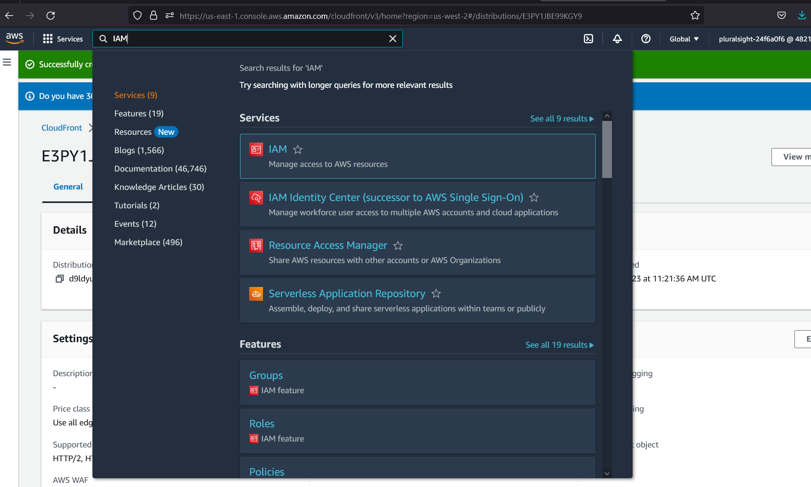



**Assignement-2 :** Create an IAM policy that allows the user to read and write to an S3 bucket and attach it to the user.

**Assignment – 3 : Create an IAM group and add the user to it. Launch an EC2 instance and assign the IAM role to it.**

